Instructions
For each of the sentences below, please complete three steps.
- Complete the Sentence Labeling Table (abbreviations are found on the next page.

- Please identify the Sentence Pattern for each sentence. You can find a good guide on page 24 in Rhetorical Grammar. . These labels also match the example trees in my "Tree Handout.." Different books number and name these patterns differently, so please describe the sentence pattern using one of these options:
- Copular "Be" (pattern 1 and 2. on p. 24)
- Linking Verb with a Subject Complement (pattern 3 on p. 24)
- Intransitive (pattern 4 on p. 24)
- Transitive (pattern 5 on p. 24)
- Ditransitive with a Direct Object (pattern 6 on p. 24)
- Ditransitive with an Object Complement (pattern 7 on p. 24)
- Please make a syntactic tree diagram for each of the sentences below. You can find examples of syntactic trees for each type in Chapter 8 and in my Tree Handout.
- Please be sure that you do include a phrase level for all NPs, VPs, ADJPs, ADVPs, and PPs.
- If you like, you can also include in your sentence diagram the role that a word or phrase plays in the sentence using the abbreviations on the next page, but it is not required. Indicate this by placing a slash between the word or phrase and the role it plays. For instance, NP/DO for Noun Phrase/Direct Object or PP/SC for Prepositional Phrase/Subject Complement.

Phrase Abbreviations
- NP = Noun Phrase
- VP = Verb Phrase
- ADJP = Adjective Phrase
- ADVP = Adverb Phrase
- PP = Prepositional Phrase
Part of Speech Abbreviations
- N = Noun
- V = Verb
- Adj = Adjective
- Adv = Adverb
- Prep = Preposition
- Det = Determiner
- Pro = Pronoun
Sentence Role Abbreviations
- SUB = Subject
- PRED = Predicate
- ADV = Adverbial
- DO = Direct Object
- IO = Indirect Object
- SC = Subject Complement
- OC = Object Complement

1. At first, Phillip was very nervous about this class.
ROLE | Advl |  | Subj | Pred | Subj Comp
PHRASE | PP |  | NP | VP | ADJP
WORD | At | First | Phillip | Was | Very | Nervous | About | This | Class
Part of Speech | Prep | N | N | V | Adv | Adj | Prep | Det | N
- Identify the Sentence Pattern: Copular Be
Diagram
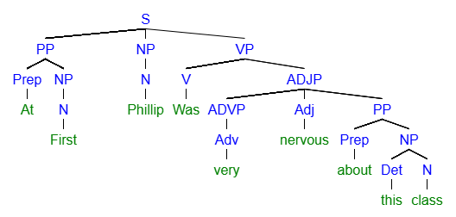
[S [PP [Prep At] [NP [N First]]] [NP [N Phillip]] [VP [V Was] [ADJP [ADVP [Adv very]] [Adj nervous] [PP [Prep about] [NP [Det this] [N class]

2. This denim jacket feels very soft.
ROLE | Subj |  |  | Pred | Subj Comp
PHRASE | NP |  |  | VP | ADJP
WORD | This | Denim | Jacket | Feels | Very | Soft
Part of Speech | Det | Adj  (or N mod) | N | V | Adv | Adj
- Identify the Sentence Pattern: Linking Verb
Diagram
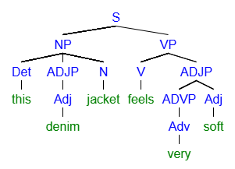
[S [NP [Det this] [ADJP [Adj denim]] [N jacket]] [VP [V feels] [ADJP [ADVP [Adv very]] [Adj soft]
3. Sadly, Sean still dates total losers.
ROLE | Advl | Subj | Pred |  | DO
PHRASE | ADVP | NP | VP |  | NP
WORD | Sadly | Sean | Still | Dates | Total | Losers
Part of Speech | Adv | N | Adv | V | Adj | N
- Identify the Sentence Pattern: Transitive with Direct Object
Diagram
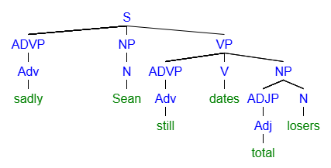
[S [ADVP [Adv sadly]] [NP [N Sean]] [VP [ADVP [Adv still]] [V dates] [NP [ADJP [Adj total]] [N losers]
4. Those creepy guys were definitely hungry zombies.
ROLE | Subj |  |  | Pred |  | Subj Comp
PHRASE | NP |  |  | VP |  | NP
WORD | Those | Creepy | Guys | Were | Definitely | Hungry | Zombies
Part of Speech | Det | Adj | N | V | Adv | Adj | N
- Identify the Sentence Pattern: Copular Be
Diagram
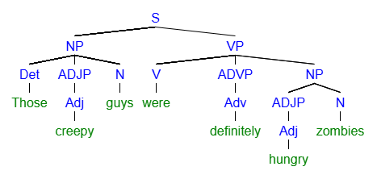
[S [NP [Det Those] [ADJP [Adj creepy]] [N guys]] [VP [V were] [ADVP [Adv definitely]] [NP [ADJP [Adj hungry]] [N zombies]

5. Her hard work made the project very successful.
ROLE | Subj |  |  | Pred | DO |  | Obj Comp
PHRASE | NP |  |  | VP | NP |  | ADJP
WORD | Her | Hard | Work | Made | The | Project | Very | Successful
Part of Speech | Det | Adj | N | V | Det | N | Adv | Adj
- Identify the Sentence Pattern: Ditransitive with Object Complement
Diagram
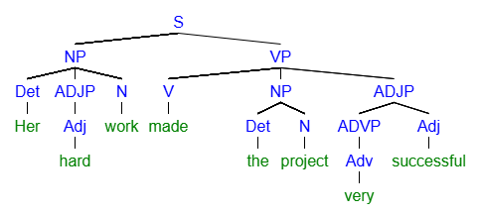
[S [NP [Det Her] [ADJP [Adj hard] [N work]]] [VP [V made] [NP [Det the] [N project]] [ADJP [ADVP [Adv very] [Adj successful]
- My father read me The Hobbit as a child.
ROLE | Subj |  | Pred | IO | DO | Advl
PHRASE | NP |  | VP | NP | NP | PP
WORD | My | Father | Read | Me | The Hobbit | As | A | Child
Part of Speech | Det | N | V | Pro | N | Prep | Det | N
- Identify the Sentence Pattern: Ditransitive with Indirect Object
Diagram
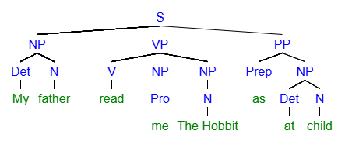
[S [NP [Det My] [N father]] [VP [V read] [NP [Pro me]] [NP [N The Hobbit]]] [PP [Prep as] [NP [Det at] [N child]
- Diligent bees hover above flowers in the afternoon.
ROLE | Subj |  | Pred | Advl |  | Advl
PHRASE | NP |  | VP | PP |  | PP
WORD | Diligent | Bees | Hover | Above | Flowers | In | The | Afternoon
Part of Speech | Adj | N | V | Prep | N | Prep | Det | N
Identify the Sentence Pattern: Intransitive
Diagram
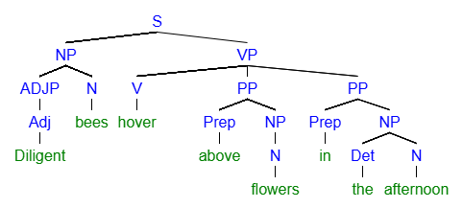
[S [NP [ADJP [Adj Diligent]] [N bees]] [VP [V hover] [PP [Prep above] [NP [N flowers]]] [PP [Prep in] [NP [Det the] [N afternoon]
- Undoubtedly, Sarah passed her extremely difficult exam with ease.
ROLE | Advl | Subj | Pred | DO |  |  | Advl
PHRASE | ADVP | NP | VP | NP |  |  | PP
WORD | Undoubtedly | Sarah | Passed | Her | Difficult | Exam | With | Ease
Part of Speech | Adv | N | V | Det | Adj | N | Prep | N
- Identify the Sentence Pattern: Transitive with Direct Object
Diagram
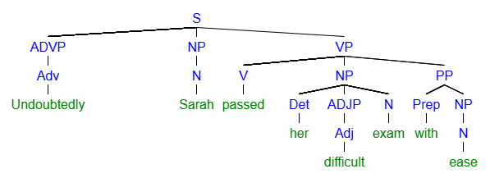
[S [ADVP [Adv Undoubtedly]] [NP [N Sarah]] [VP [V passed] [NP [Det her] [ADJP [Adj difficult]] [N exam]] [PP [Prep with] [NP [N ease]

